**DAILY REPORT**

**Student Name :SINDHU.N**

**Class and Sec : VI B**

**USN :4AL17CS094**

**DATE:02-08-2020**

|  |  |  |  |  |
| --- | --- | --- | --- | --- |
| **Online Test Details** | | | | |
| **Subject** | ------ | | | |
| **Semester** | VI -B | | **Duration** | ----------- |
| **% of marks** | | ---- | | |

|  |  |  |  |
| --- | --- | --- | --- |
| **Certification Course Details** | | | |
| **Course** | Cyber Security | | |
| **Certificate Provider** | Great Learning | **Duration** | 5.5hours |

**Snapshots of the daily class acitivities .**

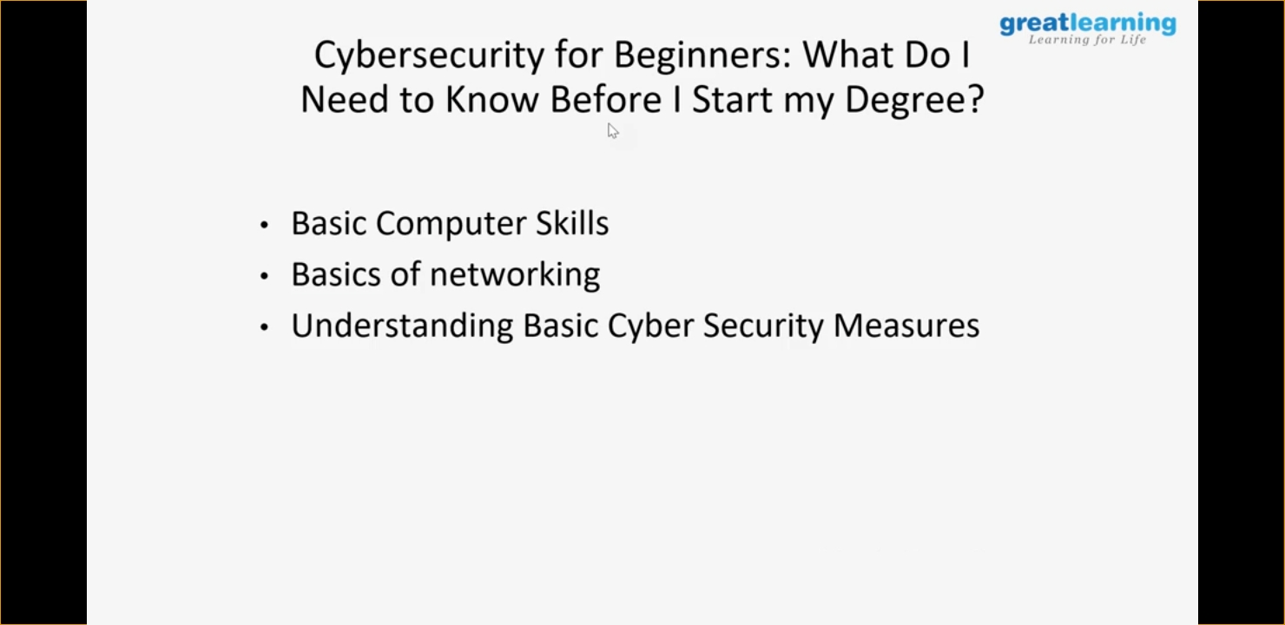

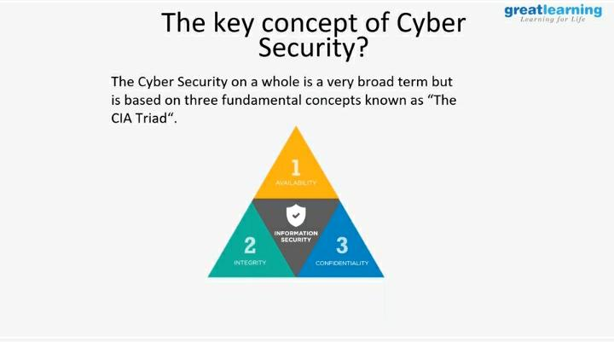

|  |  |
| --- | --- |
| **Coding Challenges** | |
| **Problem Statement: 1.Check if a triangle of positive area is possible with the given angles.** | |
| **Status:** Executed | |
| **Uploaded the report both in Github & Slack** | Yes |

**Snapshots of your response to challenge.**

1. ****Check if a triangle of positive area is possible with the given angles.****

**def isTriangleExists(a, b, c):**

**if(a != 0 and b != 0 and c != 0 and (a + b + c)== 180):**

**if((a + b)>= c or (b + c)>= a or (a + c)>= b):**

**return "YES"**

**else:**

**return "NO"**

**else:**

**return "NO"**

**a, b, c = 50, 60, 70**

**print(isTriangleExists(50, 60, 70))**

****OUTPUT****

